STEP 1:

TASK; Discuss six questions that you would ask the client giving reasons why each question is important

1. Website goals and strategies – critical for the long term success of your website
2. Design preferences – to know the color schemes, and style of the client
3. Target audience – to know the demographics, preferences, behaviors and goals to create a website that appeals to them
4. Timeline for the project – to plan and finish the project in time
5. What content will be included on the project – to plan the structure and the visual elements
6. Any competitors – to create a design that makes the stand out

Home page sketch

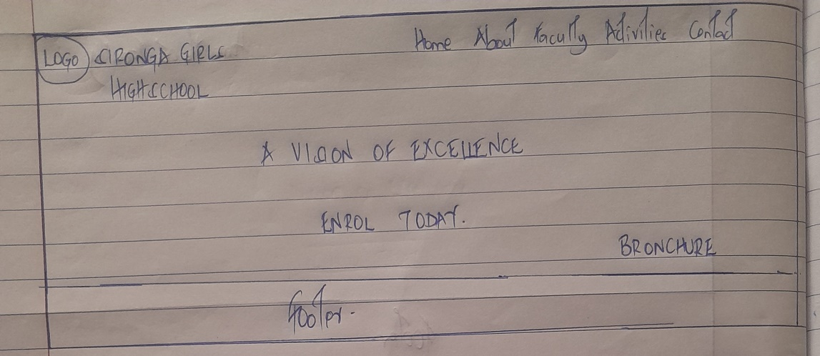

About page sketch

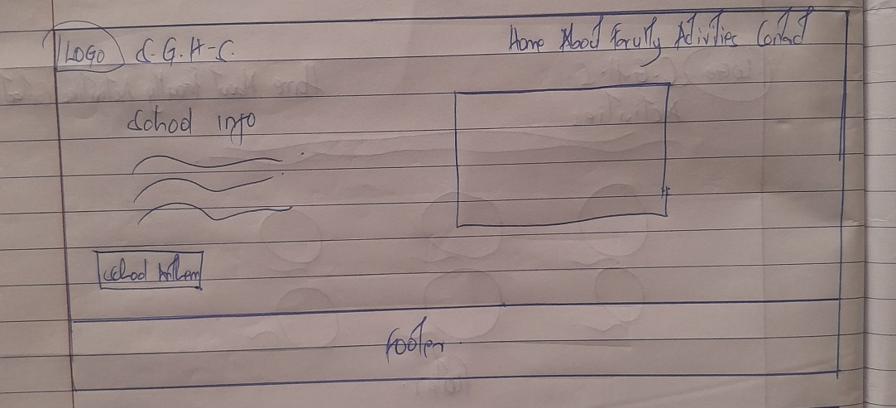

Faculty page sketch

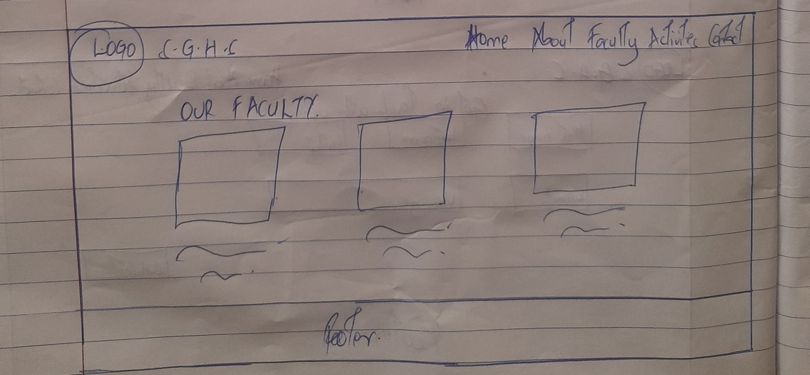

Activities page sketch

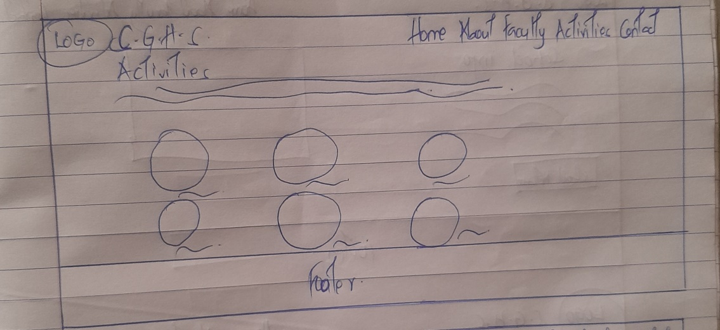

Contact page sketch

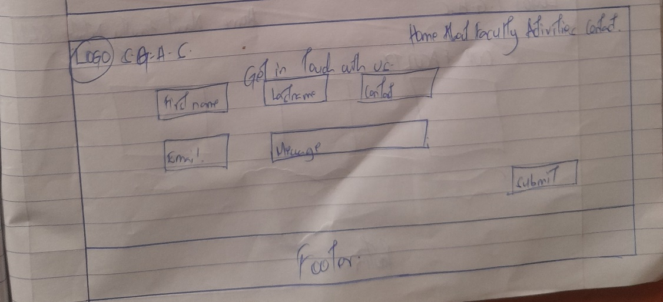

Home page wire frame

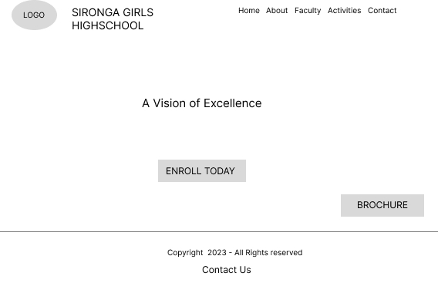

Home page prototype



About page wireframe

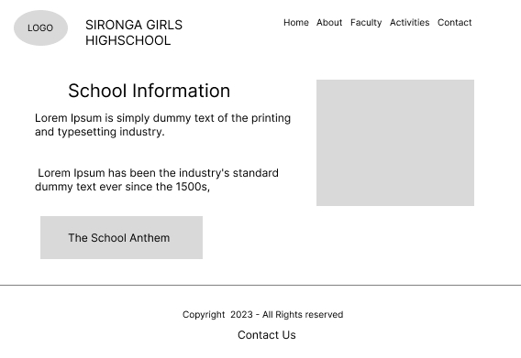

About page prototype

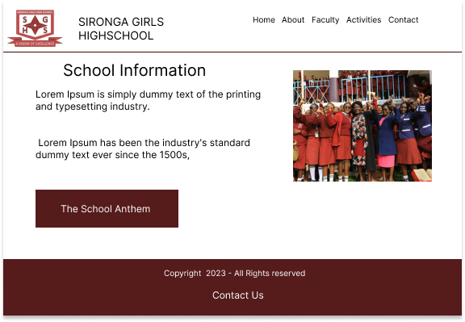

Faculty page wireframe

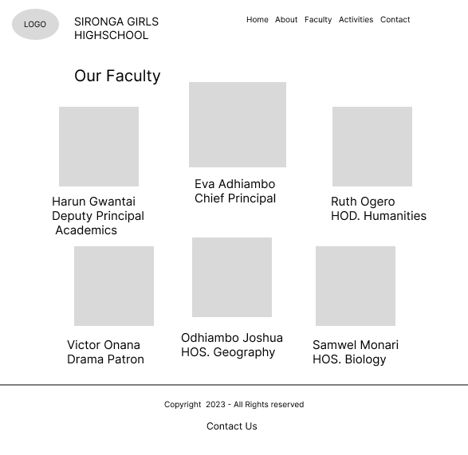

Faculty page prototype



Activities page wireframe

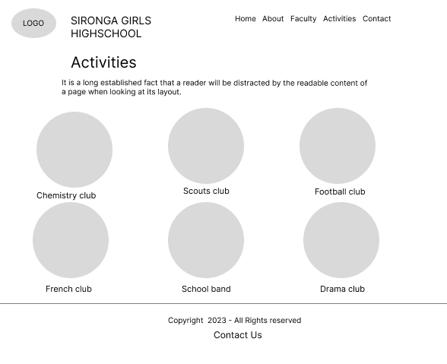

Activities page prototype

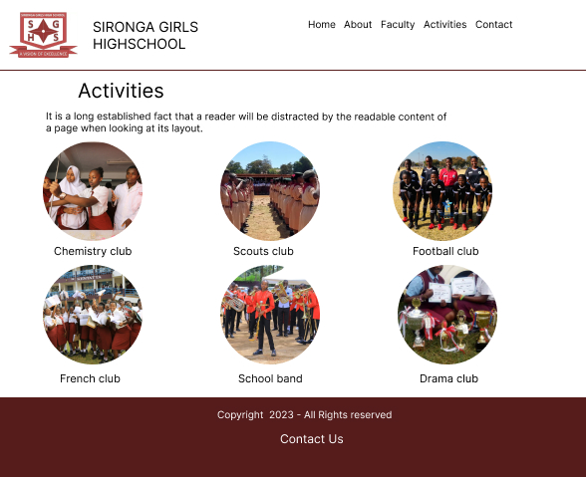

Contact page wireframe

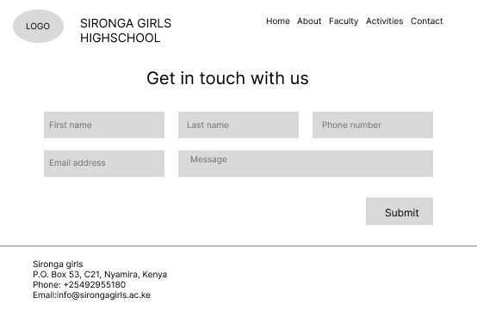

Contact page prototype

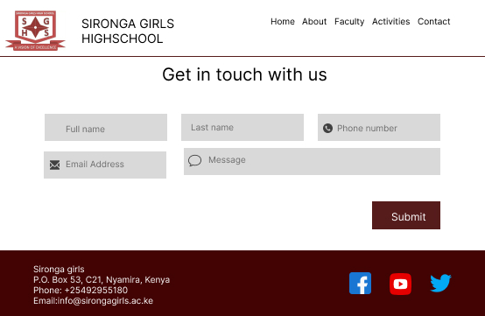

https://www.figma.com/file/008DOQqBZuMAT6h6jg9ln9/Untitled?type=design&node-id=0%3A1&mode=design&t=aG3KsAnFIXnRkIH3-1